Introduction
This report details the design and implementation of a Public Health Clinic Records System using MySQL, fulfilling the requirements of the Introduction to Database final project. The project aims to demonstrate practical database design, implementation, and management skills, aligning with Sustainable Development Goal 3: Good Health and Well-being.

Refined Physical Data Model
Based on the initial assignment, a refined Physical Data Model has been developed to ensure a well-structured and logically consistent relational database. The chosen domain is a Public Health Clinic Records System, which addresses the need for efficient management of patient, staff, appointment, medical record, billing, and payment information within a healthcare context.

Entity-Relationship Diagram (ERD)
The following Entity-Relationship Diagram visually represents the entities within the Public Health Clinic Records System and their relationships:

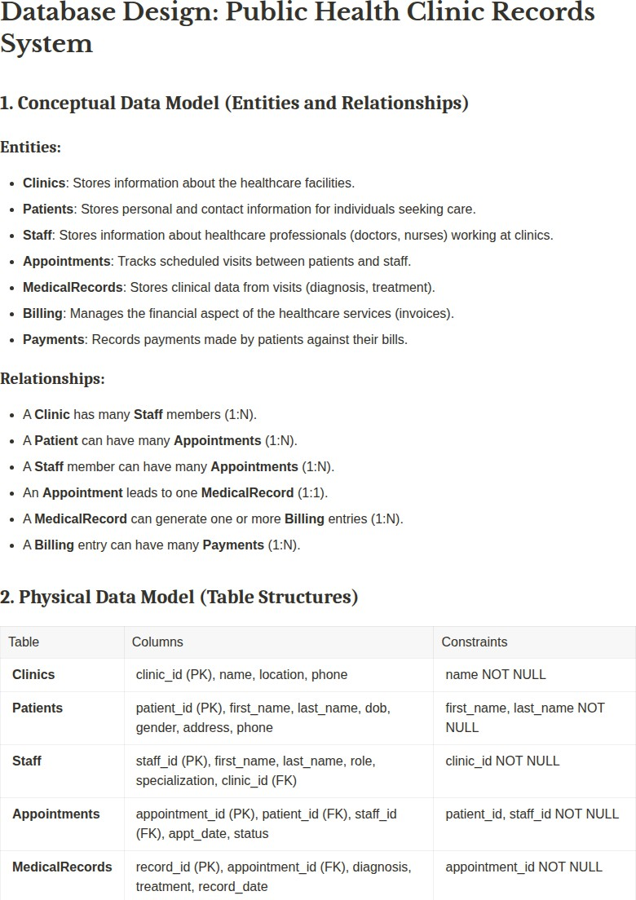

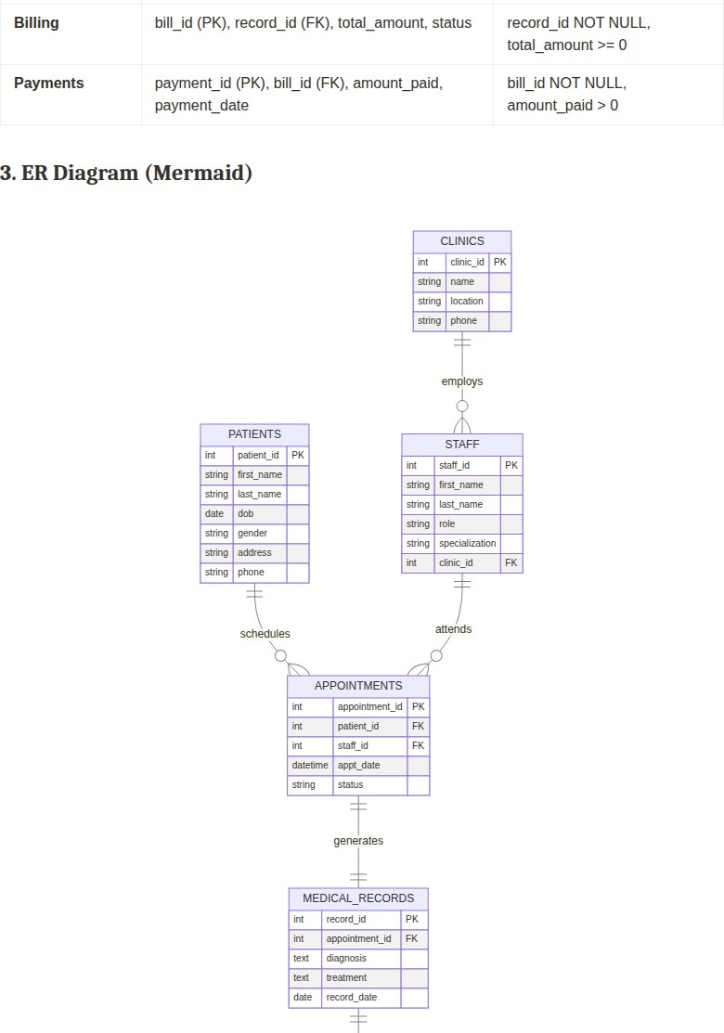

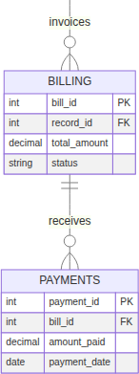

Design Decisions: Data Types and Relationships
The database schema is designed with careful consideration of data integrity, efficiency, and scalability. Key design decisions include:

    - Primary Keys (PK): Auto-incrementing integer primary keys are used for all tables (e.g.,
, ) to ensure unique identification and simplify data management.
clinic_id
patient_id
    - Foreign Keys (FK): Foreign keys are established to enforce referential integrity between
clinic_id
Staff
Clinics

related tables (e.g.,
in
references
). This ensures that

relationships between entities are maintained consistently.
    - Data Types: Appropriate data types have been selected for each attribute to optimize storage and ensure data validity. For instance, VARCHAR for names and addresses,
DATE
DATETIME

for birth dates,
for appointment times, TEXT for longer descriptions like

diagnosis and treatment, and DECIMAL(10, 2) for monetary values to ensure precision.
    - Constraints: NOT NULL constraints are applied to essential fields (e.g., in
name
last_name
Patients
Staff

, first_name ,
Clinics
in
and
) to guarantee data

completeness. ENUM types are used for fields with a predefined set of values (e.g.,
Billing

, status in Appointments and
gender
) to restrict input and improve data

consistency. CHECK constraints are used for numerical fields to ensure logical data ranges
amount_paid > 0
Payments

(e.g., total_amount = 0 in Billing ,
in ).

SQL Implementation
The database implementation includes SQL scripts for database creation, table definition with constraints, sample data insertion, and various query examples.

Data’base and Table Creation Scripts

- Database Creation
DROP DATABASE IF EXISTS public_health_clinic; CREATE DATABASE public_health_clinic;
USE public_health_clinic;

- Table Creation CREATE TABLE Clinics (
clinic_id INT AUTO_INCREMENT PRIMARY KEY,
name VARCHAR(255) NOT NULL,
location VARCHAR(255), phone VARCHAR(20)
);

CREATE TABLE Patients (
patient_id INT AUTO_INCREMENT PRIMARY KEY,
first_name VARCHAR(100) NOT NULL, last_name VARCHAR(100) NOT NULL,
dob DATE,
gender ENUM(\'Male\', \'Female\', \'Other\'), address VARCHAR(255),
phone VARCHAR(20)
);

CREATE TABLE Staff (
staff_id INT AUTO_INCREMENT PRIMARY KEY,
first_name VARCHAR(100) NOT NULL, last_name VARCHAR(100) NOT NULL, role VARCHAR(100),
specialization VARCHAR(100), clinic_id INT,
FOREIGN KEY (clinic_id) REFERENCES Clinics(clinic_id)
);

CREATE TABLE Appointments (
appointment_id INT AUTO_INCREMENT PRIMARY KEY, patient_id INT NOT NULL,
staff_id INT NOT NULL,
appt_date DATETIME NOT NULL,
status ENUM(\'Scheduled\', \'Completed\', \'Cancelled\') DEFAULT \'Sc FOREIGN KEY (patient_id) REFERENCES Patients(patient_id),
FOREIGN KEY (staff_id) REFERENCES Staff(staff_id)

);

CREATE TABLE MedicalRecords (
record_id INT AUTO_INCREMENT PRIMARY KEY,
appointment_id INT NOT NULL UNIQUE, diagnosis TEXT,
treatment TEXT, record_date DATE,
FOREIGN KEY (appointment_id) REFERENCES Appointments(appointment_id)
);

CREATE TABLE Billing (
bill_id INT AUTO_INCREMENT PRIMARY KEY,
record_id INT NOT NULL,
total_amount DECIMAL(10, 2) NOT NULL CHECK (total_amount = 0), status ENUM(\'Pending\', \'Paid\', \'Overdue\') DEFAULT \'Pending\',
FOREIGN KEY (record_id) REFERENCES MedicalRecords(record_id)
);

CREATE TABLE Payments (
payment_id INT AUTO_INCREMENT PRIMARY KEY,
bill_id INT NOT NULL,
amount_paid DECIMAL(10, 2) NOT NULL CHECK (amount_paid > 0), payment_date DATETIME DEFAULT CURRENT_TIMESTAMP,
FOREIGN KEY (bill_id) REFERENCES Billing(bill_id)
);

Sample Data Insertion and Manipulation Scripts

- Data Manipulation (INSERT)
INSERT INTO Clinics (name, location, phone) VALUES
(\'City Health Clinic\', \'123 Main St, Freetown\', \'232-77-123456\'), (\'Wellness Center\', \'456 Oak Ave, Bo\', \'232-78-789012\');

INSERT INTO Patients (first_name, last_name, dob, gender, address, phone) (\'Alice\', \'Smith\', \'1990-05-15\', \'Female\', \'789 Pine Ln, Freetow (\'Bob\', \'Johnson\', \'1985-11-20\', \'Male\', \'101 Elm St, Bo\', \'23 (\'Charlie\', \'Brown\', \'1992-03-01\', \'Male\', \'202 Maple Dr, Freeto
INSERT INTO Staff (first_name, last_name, role, specialization, clinic_id (\'Dr. Emily\', \'White\', \'Doctor\', \'General Practitioner\', 1), (\'Nurse Sarah\', \'Davis\', \'Pediatrics\', 1),
(\'Dr. John\', \'Doe\', \'Doctor\', \'Cardiology\', 2);

INSERT INTO Appointments (patient_id, staff_id, appt_date, status) VALUES
(1, | 1, | \'2026-06-20 | 10:00:00\', | \'Completed\'),
(2, | 3, | \'2026-06-22 | 11:30:00\', | \'Scheduled\'),
(1, | 2, | \'2026-06-25 | 09:00:00\', | \'Scheduled\');

INSERT INTO MedicalRecords (appointment_id, diagnosis, treatment, record_ (1, \'Common Cold\', \'Rest and fluids\', \'2026-06-20\');

INSERT INTO Billing (record_id, total_amount, status) VALUES (1, 50.00, \'Pending\');

INSERT INTO Payments (bill_id, amount_paid) VALUES (1, 30.00);

- Data Manipulation (UPDATE) UPDATE Patients
SET address = \'888 New Rd, Freetown\' WHERE patient_id = 1;

UPDATE Appointments
SET status = \'Cancelled\' WHERE appointment_id = 3;

- Data Manipulation (DELETE)
- First, delete dependent records (payments, billing, medical records, a DELETE FROM Payments WHERE bill_id IN (SELECT bill_id FROM Billing WHERE
DELETE FROM Billing WHERE record_id IN (SELECT record_id FROM MedicalRecords DELETE FROM MedicalRecords WHERE appointment_id = 3;
DELETE FROM Appointments WHERE appointment_id = 3;

SQL Query Examples

- SQL Queries

- 1. Select all patients SELECT * FROM Patients;

- 2. Select appointments scheduled for a specific date (Filtering with W SELECT * FROM Appointments
WHERE appt_date LIKE \'2026-06-22%\';

- 3. Select staff ordered by last name (Sorting with ORDER BY) SELECT first_name, last_name, role FROM Staff
ORDER BY last_name ASC;

- 4. Count total patients (Aggregate function COUNT) SELECT COUNT(*) AS TotalPatients FROM Patients;

- 5. Calculate total amount billed (Aggregate function SUM) SELECT SUM(total_amount) AS TotalBilledAmount FROM Billing;

- 6. Find average payment amount (Aggregate function AVG) SELECT AVG(amount_paid) AS AveragePaymentAmount FROM Payments;

- 7. Select top 2 upcoming appointments (LIMIT) SELECT * FROM Appointments
WHERE status = \'Scheduled\'
ORDER BY appt_date ASC LIMIT 2;

- 8. Total amount billed per patient
SELECT p.first_name, p.last_name, SUM(b.total_amount) AS TotalBilled FROM Patients p
JOIN Appointments a ON p.patient_id = a.patient_id
JOIN MedicalRecords mr ON a.appointment_id = mr.appointment_id JOIN Billing b ON mr.record_id = b.record_id
GROUP BY p.patient_id;

- 9. Total payments for a specific bill
SELECT b.bill_id, SUM(py.amount_paid) AS TotalPaidForBill FROM Billing b
JOIN Payments py ON b.bill_id = py.bill_id
WHERE b.bill_id = 1

GROUP BY b.bill_id;

- 10. Patients with outstanding bills
SELECT p.first_name, p.last_name, (b.total_amount - COALESCE(SUM(py.amoun FROM Patients p
JOIN Appointments a ON p.patient_id = a.patient_id
JOIN MedicalRecords mr ON a.appointment_id = mr.appointment_id JOIN Billing b ON mr.record_id = b.record_id
LEFT JOIN Payments py ON b.bill_id = py.bill_id
GROUP BY p.patient_id, b.bill_id, b.total_amount HAVING OutstandingBalance > 0;

Basic User Management
Basic user management concepts are demonstrated to ensure database security and controlled access. This includes creating user accounts, assigning specific privileges, and altering passwords.

- Basic User Management
- Create a user for a group member (replace \'group_member1\' and \'pass CREATE USER \'group_member1\'@\'localhost\' IDENTIFIED BY \'password123\'

- Grant privileges to the user for the public_health_clinic database GRANT SELECT, INSERT, UPDATE, DELETE ON public_health_clinic.* TO \'group

- Flush privileges to apply changes FLUSH PRIVILEGES;

- Change password for a user
ALTER USER \'group_member1\'@\'localhost\' IDENTIFIED BY \'new_strong_pas

- Create another user with limited privileges (e.g., read-only for a spe CREATE USER \'auditor\'@\'localhost\' IDENTIFIED BY \'auditpass\';
GRANT SELECT ON public_health_clinic.MedicalRecords TO \'auditor\'@\'loca FLUSH PRIVILEGES;

Conclusion
This project successfully designed and implemented a Public Health Clinic Records System using MySQL, demonstrating proficiency in database creation, table definition with constraints, data manipulation, and complex querying. The system provides a robust foundation for managing essential healthcare data, adhering to best practices in relational database design and security. The implementation of user management features further enhances the system’s integrity and access control. This project serves as a comprehensive demonstration of the skills acquired in database management and design.

